**SHIVI AI Desktop Voice Assistant**

An AI personal assistant is a piece of software that understands verbal or written commands and completes task assigned by the client. It is an example of weak AI that is it can only execute and perform quest designed by the user.

The implemented voice assistant can perform the following task it can open YouTube, Gmail, Google chrome and stack overflow. Predict current time, take a photo, search Wikipedia to abstract required data, predict weather in different cities, get top headline news from Times of India and can answer computational and geographical questions too.

## **Packages required:**

To build a personal voice assistant it’s necessary to install the following packages in your system using the pip command.

1. Pyttsx --- pyttxs3 is a text to speech conversion library in python. This package supports text to speech engines on Mac os x, Windows and on Linux.

A python library that will help us to convert text to speech. In short, it is text-to-speech library.

It works offline, and it is compatible with Python 2 as well as Python 3.

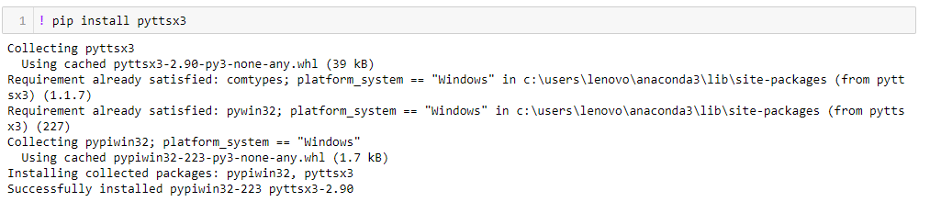

1. Speech recognition ----- It is an important feature used in house automation and in artificial intelligence devices. The main function of this library is it tries to understand whatever the humans speak and converts the speech to text.

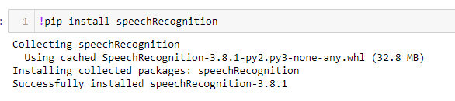

1. **wikipedia** — Wikipedia is a multilingual online encyclopedia used by many people from academic community ranging from freshmen to students to professors who wants to gain information over a particular topic. This package in python extracts data’s required from Wikipedia.

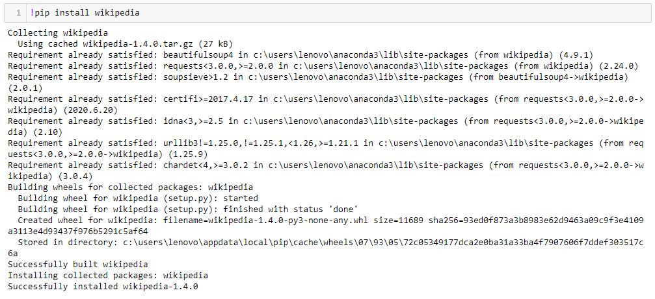

**4) datetime** — This is an inbuilt module in python and it works on date and time

5)  **os** — This module is a standard library in python and it provides the function to interact with operating system

6) **time**— The time module helps us to display time

7) **Web browser** — This is an in-built package in python. It extracts data from the web

9) **Subprocess** — This is a standard library use to process various system commands like to log off or to restart your PC.

## **Setting up the speech engine:**

The **pyttsx3** module is stored in a variable name engine.

**Sapi5** is a Microsoft Text to speech engine used for voice recognition.

The voice Id can be set as either 0 or 1,

0 indicates Male voice

1 indicates Female voice

Now define a function **speak** which converts text to speech. The speak function takes the text as its argument, further initialize the engine.

## **Initiate a function to greet the user:**

Define a function **wishMe** for the AI assistant to greet the user.

The**now().hour** function abstract’s the hour from the current time.

If the hour is greater than zero and less than 12, the voice assistant wishes you with the message “Good Morning”.

If the hour is greater than 12 and less than 18, the voice assistant wishes you with the following message “Good Afternoon”.

Else it voices out the message “Good evening”

## **The Main function:**

The main function starts from here, the commands given by the humans is stored in the variable **statement**.

If the following trigger words are there in the statement given by the users it invokes the virtual assistant to speak the below following commands.

## **Skill 1 -Fetching data from Wikipedia:**

The following commands helps to extract information from wikipedia. The **wikipedia.summary()** function takes two arguments, the statement given by the user and how many sentences from wikipedia is needed to be extracted is stored in a variable **result.**

## **Skill 2 -Accessing the Web Browsers — Google chrome , G-Mail and YouTube:**

The web browser extracts data from web. The **open_new_tab** function accepts **URL**as a parameter that needs to be accessed.

The**Python time sleep function** is used to add delay in the execution of a program. We can use this function to halt the execution of the program for given **time** in seconds.

## **Skill 3 -Predicting time:**

The current time is abstracted from **datetime.now()** function which displays the hour, minute and second and is stored in a variable name **strTime.**

## **Skill 4 -To fetch latest news:**

If the user wants to know the latest news , The voice assistant is programmed to fetch top headline news from Time of India by using the web browser function.

## **Skill 5-Searching data from web:**

From the **web browser** you can **search** required data by passing the user statement (command) to the **open_new_tab()** function.